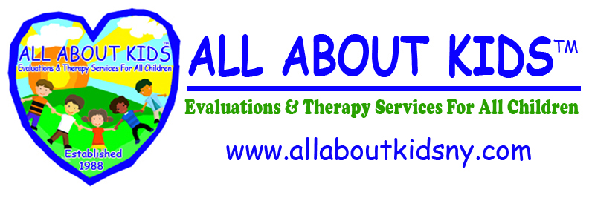

PARENTAL WAIVER OF BILINGUAL EVALUATION SUMMARY

CHILD’S NAME: ________________________________________

The Bilingual Evaluations Program Guidelines indicates that: To the extent feasible and within the parent’s preference, consent, and confidentiality requirements, the written and oral summary of the evaluation must be provided in the dominant language or other mode of communication to the parent.

I am aware that I am entitled to receive my child’s evaluation summary in my dominant language. However, I waive that right and I am requesting the reports in English only.

_________________________________________ ____________________
Parent’s Signature Date

Executive Office  Nassau | Suffolk | Queens  Manhattan | Brooklyn | Bronx | Westchester
255 Executive Drive,  Suite LL 105/108  Plainview, NY 11803  516-576-2040  Fax: 516-576-2131 | 150 Vanderbilt Motor Pkwy, Suite 401  Hauppauge, NY 11788  631-439-6860  Fax: 631-439-6861 | 37-11 35th Ave,  Suite 3C  Astoria, NY 11101  718-706-7500  Fax: 718-706-9595 | 25 Chapel Street,  Suite 704  Brooklyn, NY 11201  718-522-7300  Fax: 718-522-5280 | 3140B  E.Tremont Avenue  Bronx, NY 10461  718-239-4147  Fax: 718-239-4310 | 145 Huguenot Street  Suite 404  New Rochelle, NY 10801  914-251-0905  Fax: 914-251-1266
www.allaboutkidsny.com

