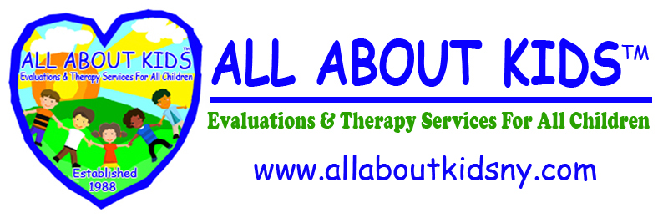

PERMISSION TO EVALUATE FOR

EARLY INTERVENTION

I, _________________________________ give permission to
All About Kids to evaluate my child. This evaluation may include a Speech Evaluation, Special Education Evaluation, Medical Report, and any other evaluations applicable to my child’s needs and/or required by New York State Regulations. I am aware that I will be receiving a copy of my child’s evaluations and that the evaluation site will be contacting me to ensure that I have received the evaluations and to answer any questions I may have regarding the results. I am also aware that by signing this form, I am only giving consent for my child to be evaluated, and does not apply to any services, which may be recommended.

_____________________________________________
(Parent/Guardian’s Signature)

________________________________
(Date)

Executive Office  Nassau | Suffolk | Queens  Manhattan | Brooklyn | Bronx | Westchester
255 Executive Drive,  Suite LL 105/108  Plainview, NY 11803  516-576-2040  Fax: 516-576-2131 | 150 Vanderbilt Motor Pkwy, Suite 401  Hauppauge, NY 11788  631-439-6860  Fax: 631-439-6861 | 37-11 35th Ave,  Suite 3C  Astoria, NY 11101  718-706-7500  Fax: 718-706-9595 | 25 Chapel Street,  Suite 704  Brooklyn, NY 11201  718-522-7300  Fax: 718-522-5280 | 3140B  E.Tremont Avenue  Bronx, NY 10461  718-239-4147  Fax: 718-239-4310 | 145 Huguenot Street, Suite 404  New Rochelle, NY 10801  914-251-0905  Fax: 914-251-1266
www.allaboutkidsny.com

